N1
interface FastEthernet0/1
switchport trunk allowed vlan 10,110,180,190,250
interface GigabitEthernet0/1
switchport trunk native vlan 10
switchport trunk allowed vlan 10,110
switchport mode trunk
N3
interface FastEthernet0/1
switchport trunk allowed vlan 10,100,180,190,250
interface FastEthernet0/2
switchport trunk allowed vlan 10,100,180,190,250
interface GigabitEthernet0/1
switchport trunk native vlan 10
switchport trunk allowed vlan 10,100
switchport mode trunk
N5
interface Port-channel1
switchport trunk allowed vlan 10,100,110,180,190,250
interface FastEthernet0/2
switchport trunk allowed vlan 10,100,180,190,250
interface FastEthernet0/3
switchport trunk allowed vlan 10,100,110,180,190,250
N6
interface Port-channel1
switchport trunk allowed vlan 10,100,110,180,190,250
interface Port-channel2
switchport trunk allowed vlan 10,100,110,180,190,250
switchport mode trunk
interface FastEthernet0/5
switchport access vlan 200
switchport mode access
interface GigabitEthernet0/1
switchport trunk allowed vlan 10,100,110,180,190,200,250
N7
interface FastEthernet0/1
switchport trunk allowed vlan 10,100,180,190,250
interface FastEthernet0/2
switchport trunk allowed vlan 10,100,110,180,190,250
interface FastEthernet0/3
switchport trunk allowed vlan 10,100,110,180,190,250
interface GigabitEthernet0/1
switchport trunk native vlan 10
switchport trunk allowed vlan 10,100,110
switchport mode trunk
N8
interface Port-channel1
switchport trunk allowed vlan 10,100,110,180,190,250
interface FastEthernet0/1
switchport trunk allowed vlan 10,110,180,190,250
interface FastEthernet0/2
switchport trunk allowed vlan 10,100,110,180,190,250
R1
interface GigabitEthernet0/1.100
encapsulation dot1Q 100
ip address 173.103.201.233 255.255.255.248
interface GigabitEthernet0/1.110
encapsulation dot1Q 110
ip address 187.160.214.1 255.255.255.0
interface GigabitEthernet0/1.200
encapsulation dot1Q 200
ip address 198.68.240.9 255.255.255.248
Server
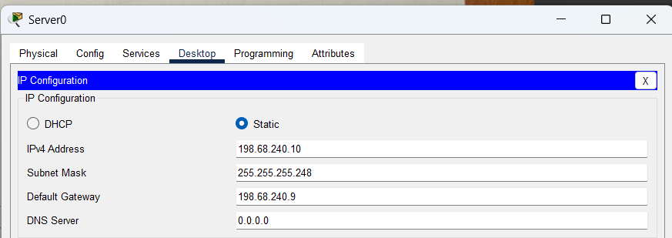
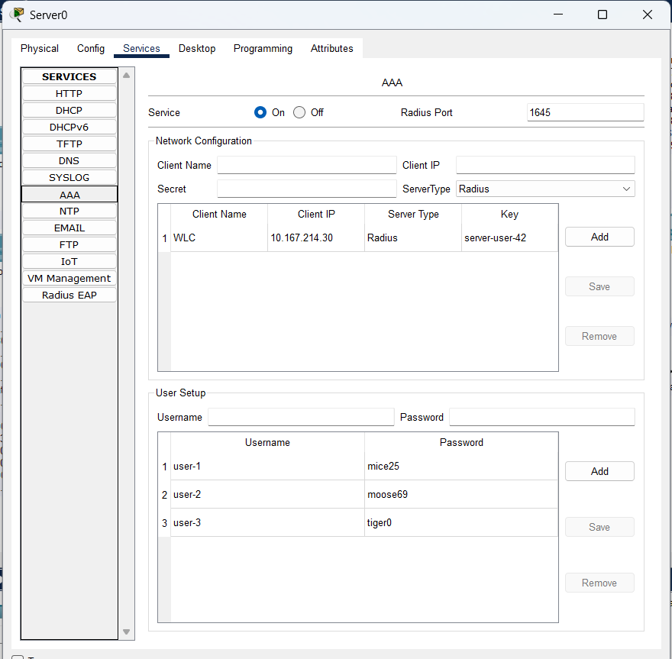
AP0
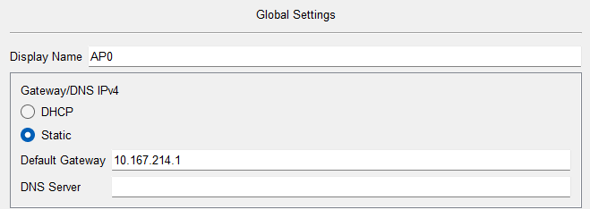
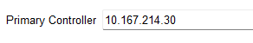
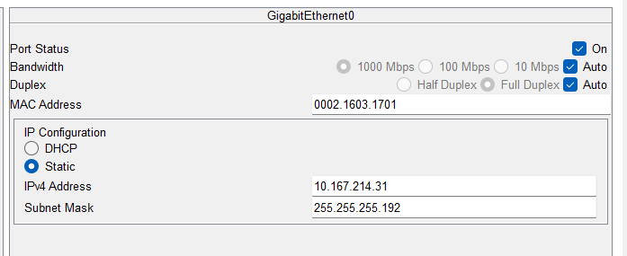
AP1
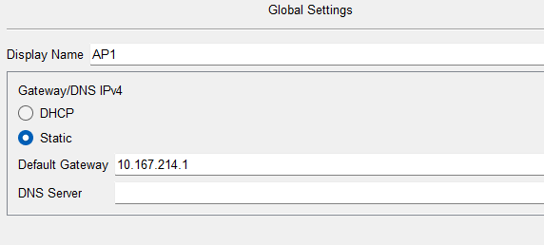
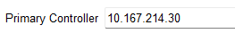
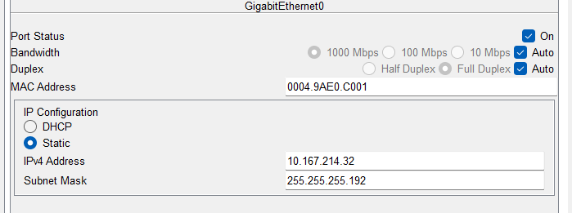

Устройства
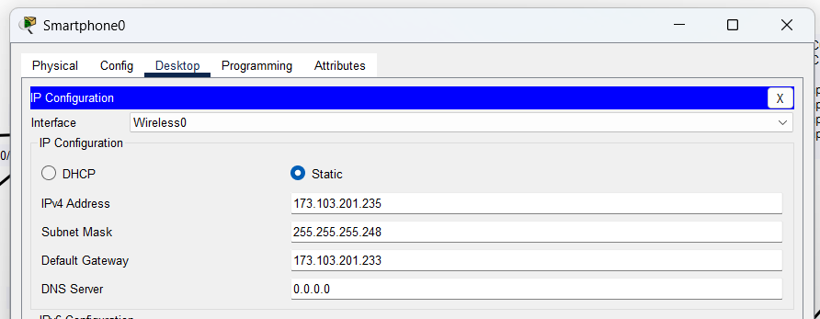
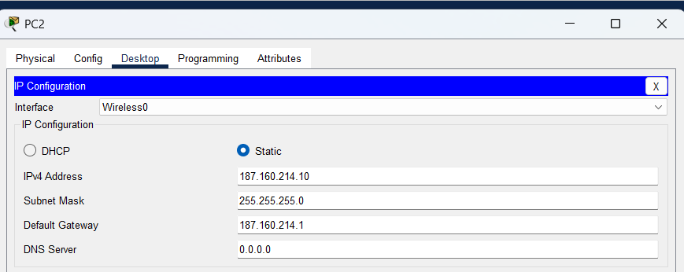
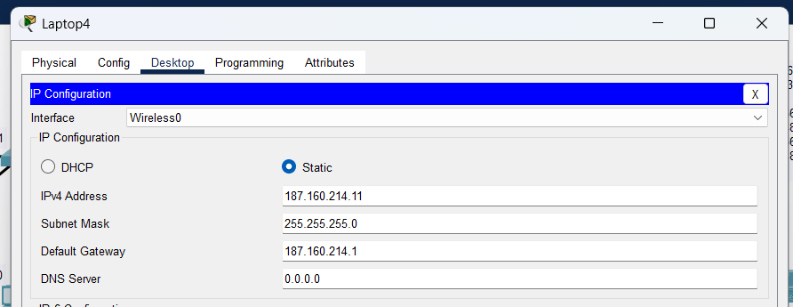
Контроллер
